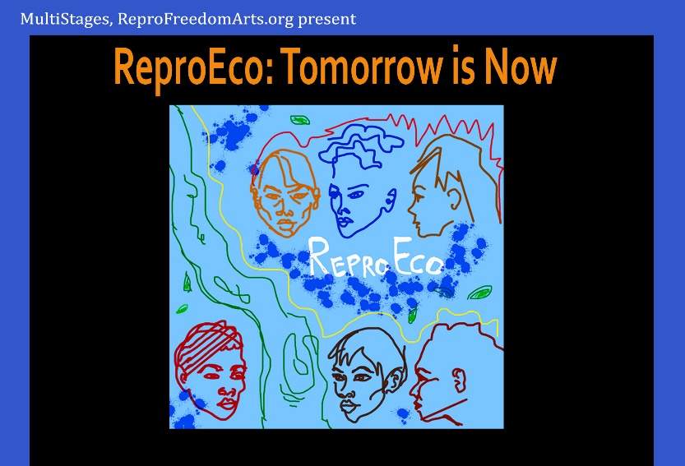
ReproEco: Tomorrow Is Now
Talkback Speakers 2026
Theatre of the 14thStY, 344 E 14 St. NYC

Sat. Sept 19, 2 pm – Cassandra Medley, award-winning playwright, and writer of the Afro-futurism piece, ‘We Are Our Ancestors Reasons for Living,’ will share her inspiration for the writing.
Wed. Sept 23, 7 pm -- Tina Rosenberg, the co-founder of Solutions Journalism, which supports the global coverage of today’s environmental challenges through solutions-based reporting; former NY Times writer, winner of Pulitzer Prize and National Book Award
Fri. Sept 25, 7 pm -- Lynn M. Paltrow, a lawyer and founder of Pregnancy Justice (formerly called National Advocates for Pregnant Women), now an activist with the Beacon for Democracy
Sat. Sept 26, 7 pm – Dr. Jacqui Patterson, founder of The Chisholm Legacy Project, which works with Black women on the frontlines of climate justice (including in Sandbranch, Texas); former director of the NAACP Environmental and Climate Justice program; Time Magazine Woman of the Year in 2024.
Thurs. Oct 1, 7 pm – Margie Kelly, Strategic Communications Manager with the Natural Resources Defense Council in Chicago, formerly a media manager with Safer Chemicals, Healthy Families; the Breast Cancer Fund; the Center for Reproductive Rights and an activist with Greenpeace; lead consultant to ReproEco: Tomorrow Is Now
Sat. Oct 3, 7 pm – Leonne Tanis, CNM, WHNP-BC: a midwife and reproductive health nurse practitioner in New York City who identifies as a Black, Haitian-American lesbian; formerly on the board of National Association to Advance Black Birth (NAABB)

