GETTING TO SEE WORDS OF CHOICE AFTER YOU’VE PURCHASED A TICKET

SCREEN ONE SAYS -- FROM AN EMAIL

Thank you so much for your ticket purchase to the first ever live-streamed performing arts festival. We so look forward to seeing you!

All you have to do to watch the show is come to http://www.VirtualArts.TV at show time and click on the link for the show you purchased!

Need a reminder? Download our mobile app in the iTunes or Android store and sign up for push notifications.

http://virtualarts.tv/mobile-app/

The app will also serve as a digital program and will let you interact with the show via pics and social chat.

Looking forward to meeting you online!

The team at VirtualArts.tv

SCREEN SHOT ONE, BELOW

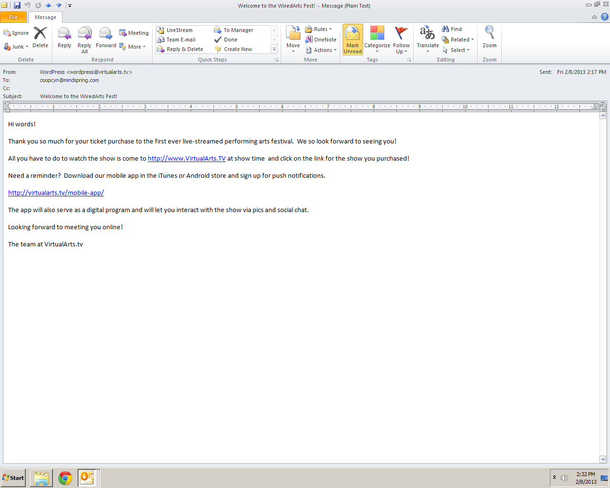

Screen Shot Two --

From Virtual Arts TV, especially the link at the top that says CALENDAR AND TICKETS:
http://virtualarts.tv/wiredartsfest/calendar-and-tickets/

Then click on the Words of Choice link for either March 1 or March 2

A screen will come up that looks like Screen Shot Two, below.

Near the bottom is text that says:

Have your tickets and ready to join us? Click here to watch the show online or to join our in-house audience head on over to...

SCREEN SHOT TWO BELOW
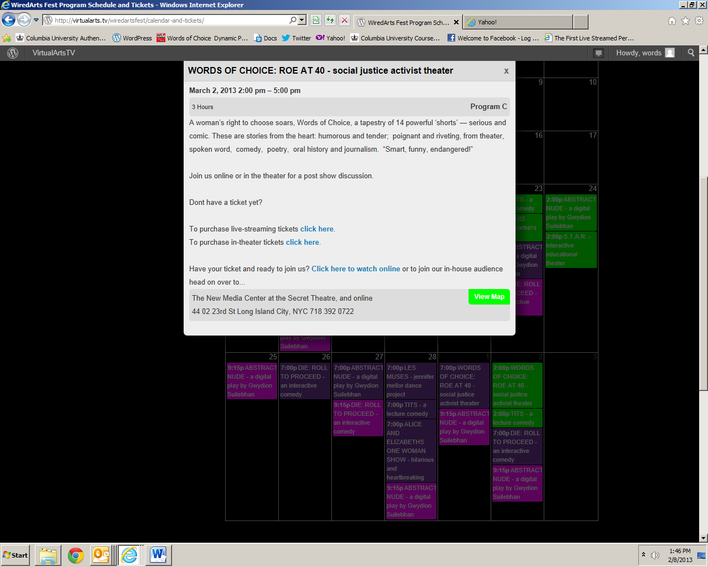

Screen Shot Three:

Clicking on the link on Screen Shot Two that says:

Have your tickets and ready to join us? Click here to watch the show online or to join our in-house audience head on over to...

Brings you to Screen Shot THREE, below.

The TEXT SAYS:
Welcome to the show! Join in the chat room or just sit back and enjoy TITS and Words of Choice: Roe at 40.
Then then second TURQUOISE BUTTON SAYS:
IF YOU HAVE A TICKET TO THIS SHOW BUT ARE SEEING THIS MESSAGE THEN YOU NEED TO LOG IN. then...just REFRESH THIS PAGE!

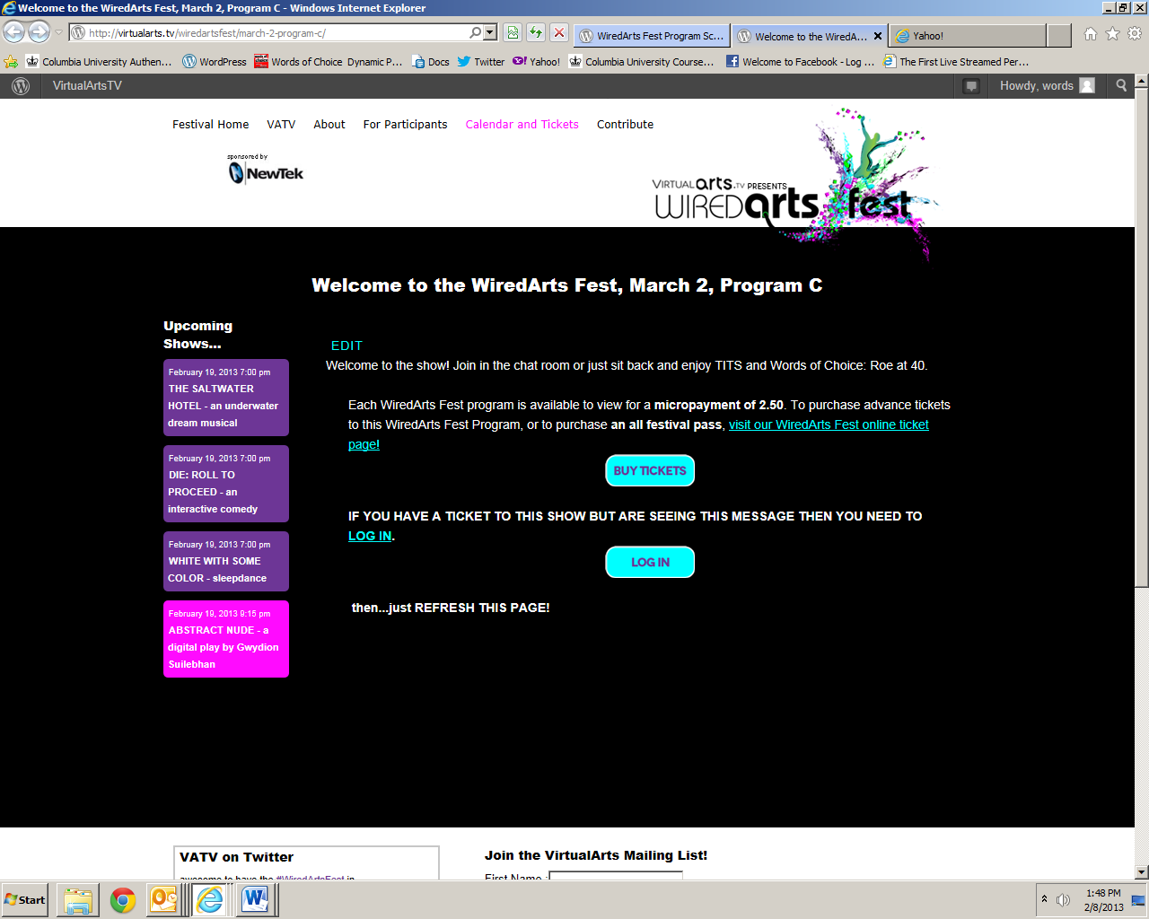

If you click on the LOG in, it looks like Screen Shot Four.

You should already have a USERNAME and PASSWORD. If you only have one, you can have an email sent to you to deal with the other.


AND THAT SHOULD DO IT!

These portals only work for the time of the show you purchased! But hopefully will work without too many glitches.

